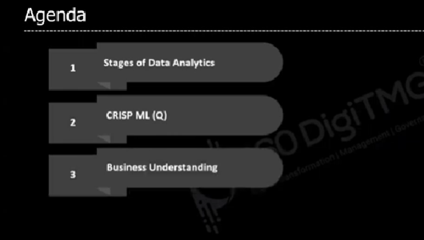

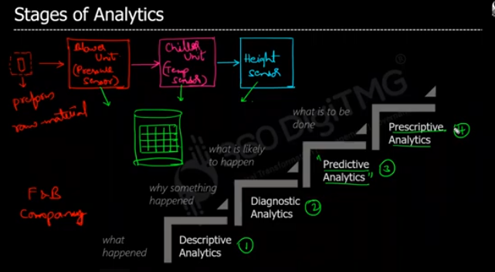

In prescriptive analysis(what should happen) we will play with predicted analysis data with the condition called “what if”, actually we will explore all the available options of predictive analysis to use the right one. From that we will know what is good, what is bad.

EX:

1. What will happen if covid 19 peoples are increased more than lakhs?
2. Should I give free vaccine?

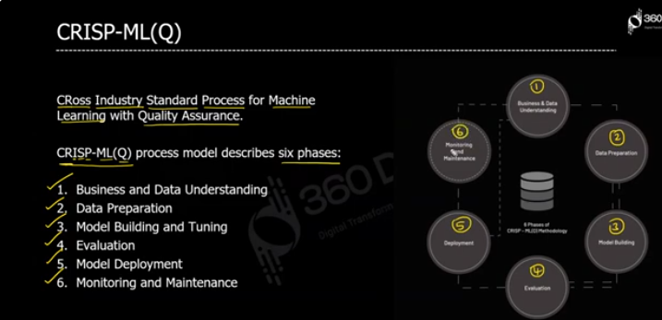

Crisp-ML is project management methodology any of your data related project. We can have multiple objectives

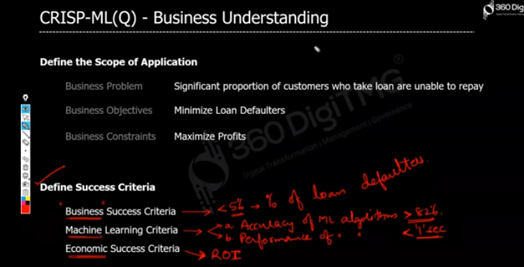

EX: Assume we developed a bank loan approver analysis system to analysis is the loner will be pay the loan in given 28 month, our model will analysis this with the loner’s age, education qualification, job status, If any one of these not satisfied well our model will rejects the loner, but if it rejects the loaner we will not have profit, so we also have to do survival analysis, and that can be done by reducing the pay loan amount days 28 to 24.

Assum model says this loaner will pay loan amount for 28 months after that there is 90% of chance the loner will not pay the loan, so we will reduce the time 28 to 24 to make more quick profit without loss.

**ALL BUSINESS UNDERSTADING STEPS (mind map link:** [**Data Science Mindmap | CRISP DM Data Science Methodology | 360DigiTMG**](https://360digitmg.com/mindmap/data-science)**)**

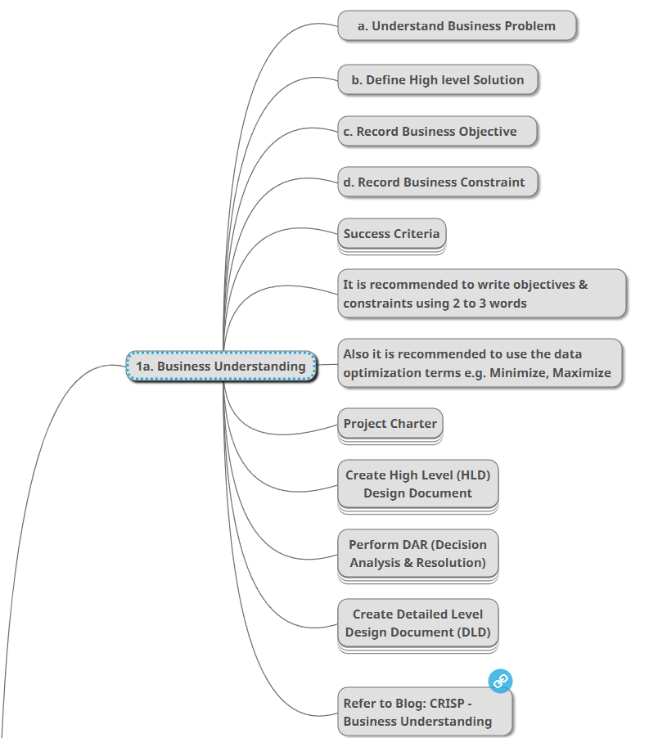

**PROJECT CHARTER**



**DATA UNDERSTANDING**

Once business understanding is finished than we have to do data analysis.

EX: if we want to predict a loner will pay the loan in given month with model, we have the search what kind of data used to predict this on existing predictive model. That is called data understanding

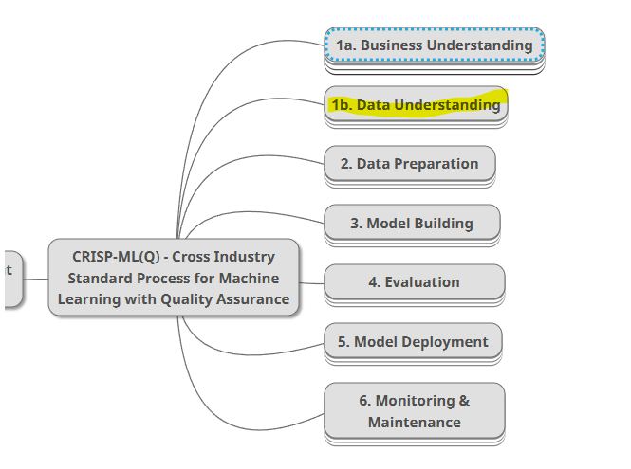

The main use of understanding the data to make analysis, to train the model with right data, with that model we have to predict, with that predict we have to which one is helps to optimize the current one, and finally that is used by management.

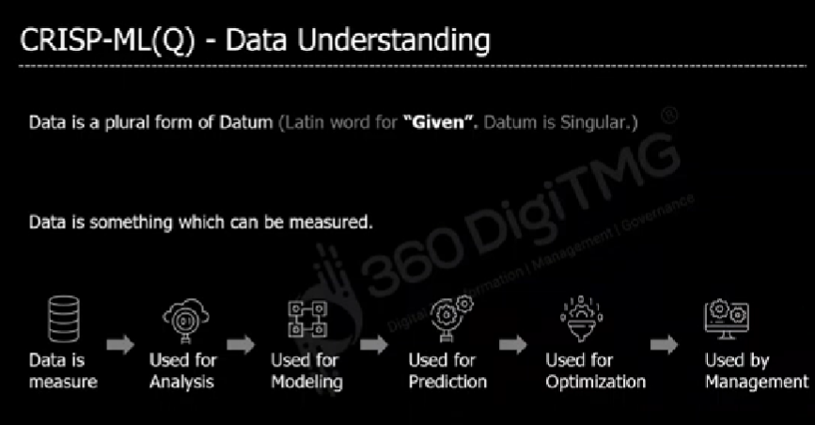

**DATA TYPES**

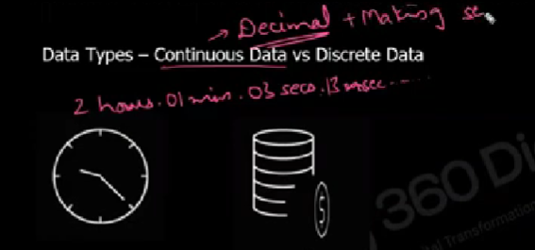

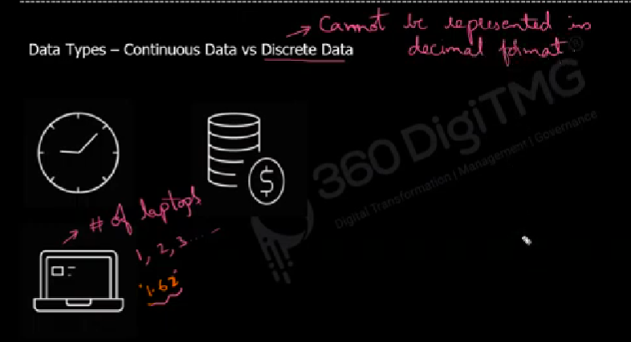

**EX for discrete Data:** We can’t say 1.62 laptops as its count

**Ex for continuous Data:** Height and weight of a person.

**CONTINOUS DATA TYPE**

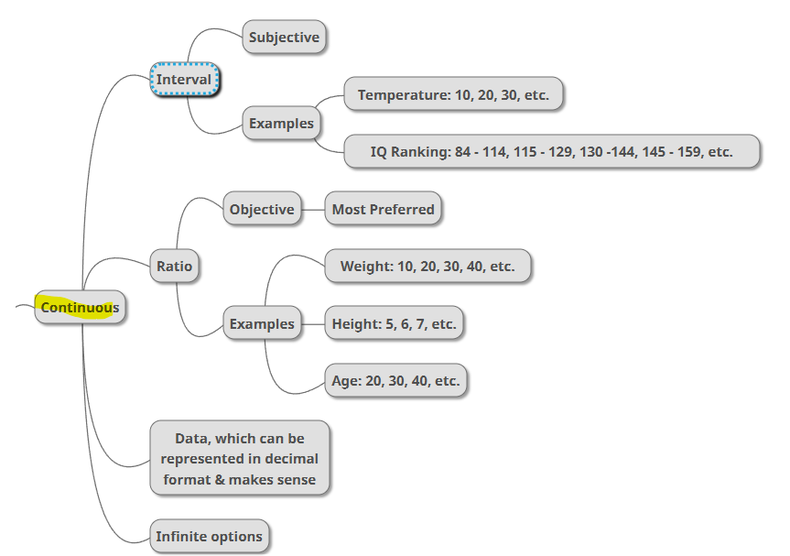

• **Interval data**: Numerical data with equal intervals but no true zero (e.g., temperature in Celsius).

• **Ratio data**: Numerical data with equal intervals and a true zero, allowing for meaningful ratios (e.g., height, weight).

**CATEGORICAL TYPES OF DATA**

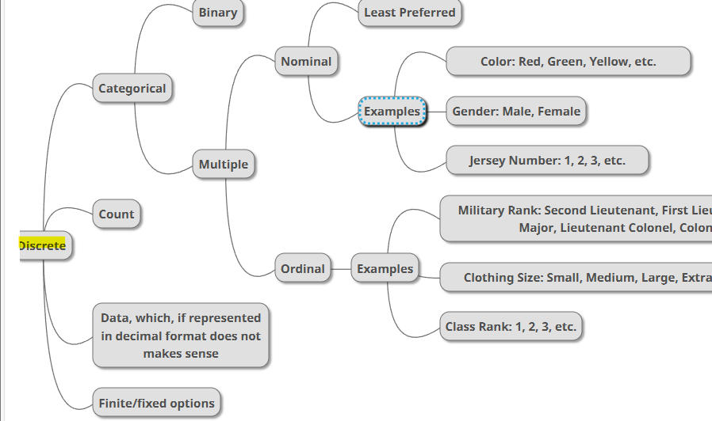

**EX for count:** Count of flight passed from some time to to time

• **Nominal data**: Categorical data without any order (e.g., colors, gender, city names).

• **Ordinal data**: Categorical data with a meaningful order but no fixed difference between values (e.g., rankings, education levels).

**MOST AND LEAST DATA USED FOR MATHMETICAL CALCULATION**

